**AWS Serverless Hackathon**

Team Name: :)Serve_less

Name: Shashibhushan Singh

AWS AC_ID: 765018985368

Mail: [pixom.ai@gmail.com](mailto:pixom.ai@gmail.com)

--Resources Information—

1. API Gateway Endpoint[: https://us-east-1.console.aws.amazon.com/apigateway/home?region=us-east-1#/apis/j1dym77yj5/resources/b9w0w6ex1f](:%20https:/us-east-1.console.aws.amazon.com/apigateway/home?region=us-east-1%23/apis/j1dym77yj5/resources/b9w0w6ex1f)

2. Lambda Function :

I) Name: Transaction Process.

II) Code: Code attached in this doc.

3. S3 Bucket name: [hackathon-2022-765018985368](https://s3.console.aws.amazon.com/s3/buckets/hackathon-2022-765018985368?region=us-east-1)

4. S3 Object URL from S3: <https://hackathon-2022-765018985368.s3.amazonaws.com/transactions.json>

5. SNS topic name: [hacathon-topic-shashibhushansingh](https://us-east-1.console.aws.amazon.com/sns/v3/home?region=us-east-1#/topic/arn:aws:sns:us-east-1:765018985368:hacathon-topic-shashibhushansingh)

6. SQS queue name:

|  |  |
| --- | --- |
|  | [hacathon-sqs-shashibhushansingh](https://us-east-1.console.aws.amazon.com/sqs/v2/home?region=us-east-1#/queues/https%3A%2F%2Fsqs.us-east-1.amazonaws.com%2F765018985368%2Fhacathon-sqs-shashibhushansingh) |

Task-1: Create a lambda function in N.Virginia regions to upload and download file from Internet.

**Solution:**

Step-1: I have created a S3 buckets and stored images and transactions.json files.

Step-2:

Created lambda function & include few python scripts to uploads and downloads files.

**Python Code used in Lambda function:**

import requests

import json

from botocore.vendored import requests

import urllib3

http = urllib3.PoolManager()

r = http.request('GET', 'http://httpbin.org/robots.txt')

print('Loading function')

s3 = boto3.client('s3')

def lambda_handler(event, context):

#print("Received event: " + json.dumps(event, indent=2))

# Get the object from the event and show its content type

bucket = event['Records'][0]['s3']['bucket']['name']

key = urllib.unquote_plus(event['Records'][0]['s3']['object']['key']).decode('utf8')

try:

response = s3.get_object(Bucket=bucket, Key=key)

s3.download_file(bucket,key, '/tmp/transactions.json')

lines = [line.rstrip('\n') for line in open('/tmp/transactions.json')]

for line in lines:

col=line.split(',')

print(col[5],col[6])

print("CONTENT TYPE: " + response['ContentType'])

return response['ContentType']

except Exception as e:

print(e)

print('Error getting object {} from bucket {}. Make sure they exist and your bucket is in the same region as this function.'.format(key, bucket))

raise e

**Screenshots:**

S3 Buckets uploaded files: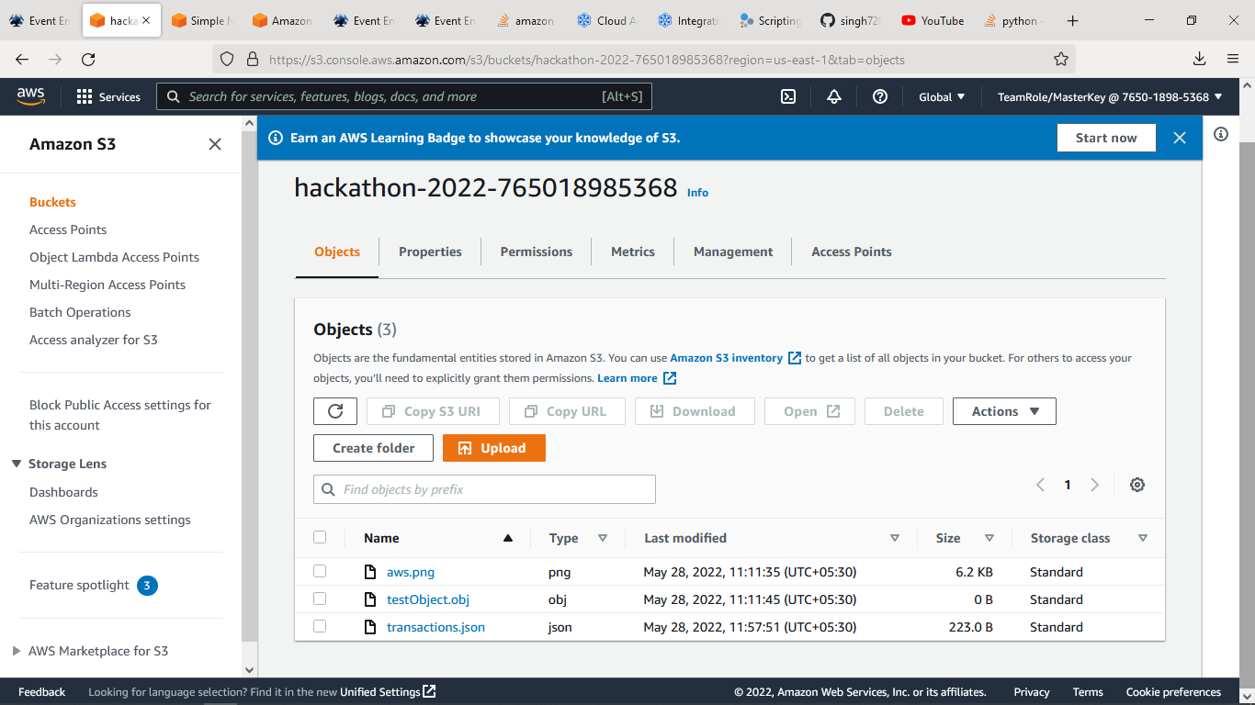

**Task-2:**

Setup Rest API with method POST & API Gatwey trigger with Lambda Functions.

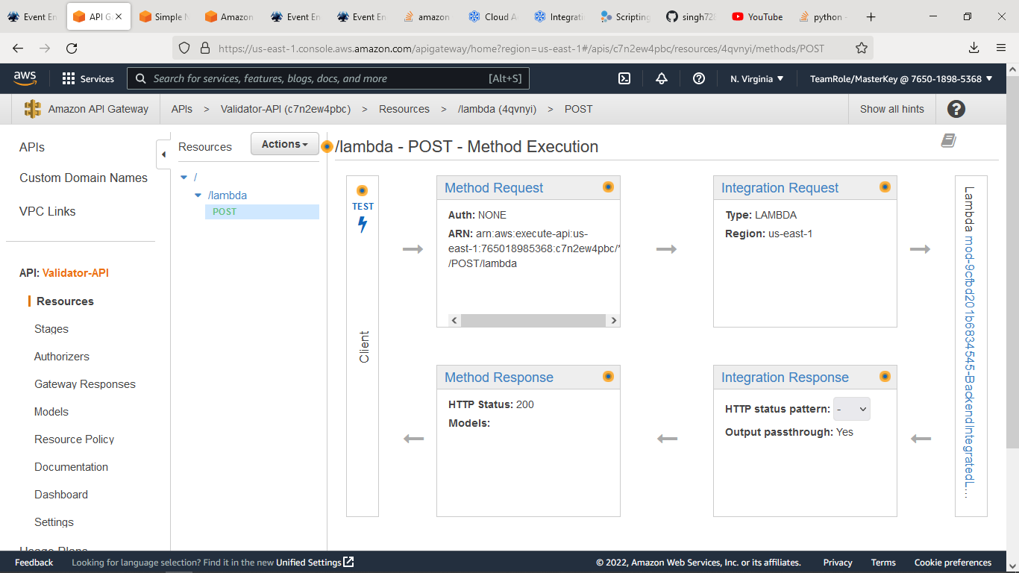

I have created API Gateway with POST method & triggered with Lambda function which I have used in Task-1.

**Task-3:**

Step-1: Create Standard SQS Topics.

I have created SQS Topics name as:

hackathon-sqs-shashibhushansingh

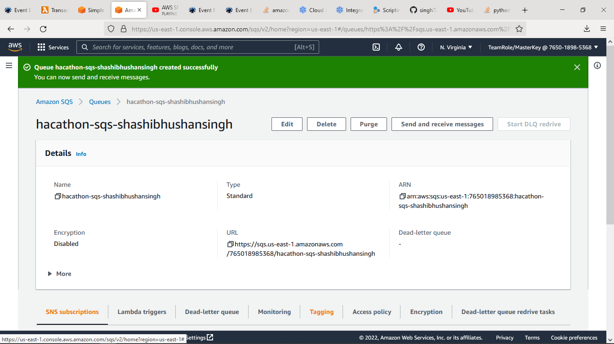

Step-2: Created SNS Topics name as:

Hackathon-sns-shashibhushansingh

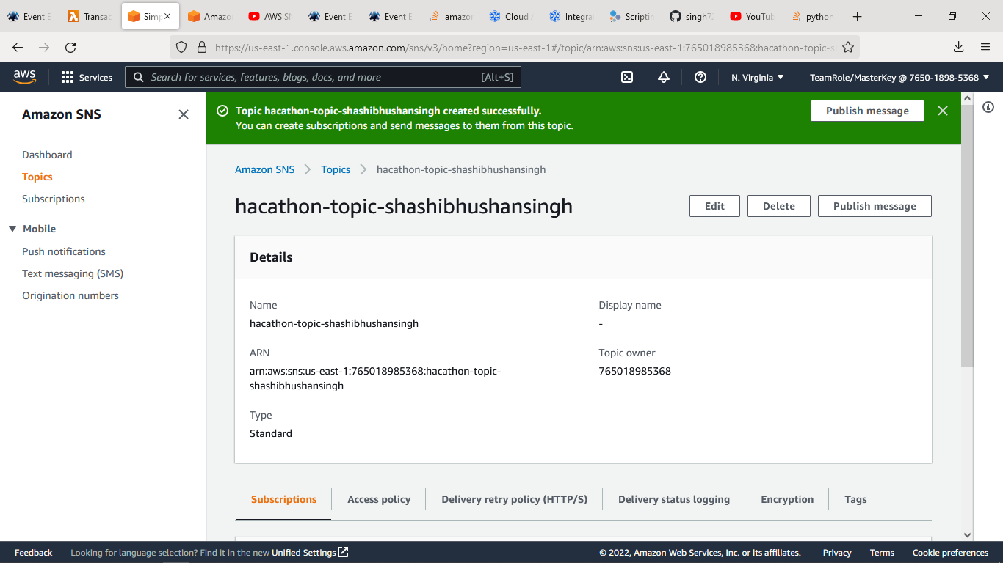

Step-3: Successfully added SQS services with SNS for S3 bucket.

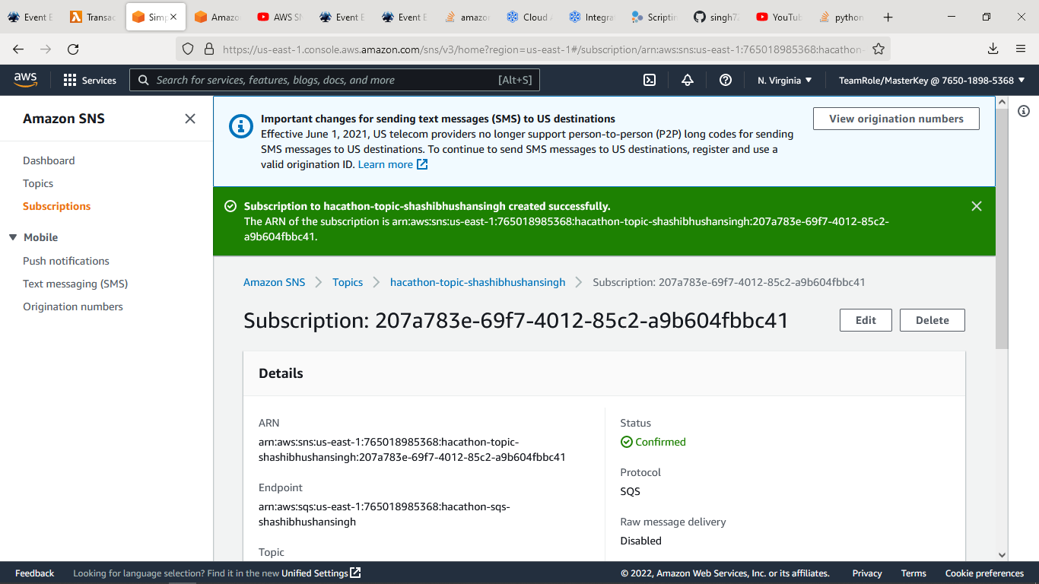

Step-4:

Successfully received and sent test messages.

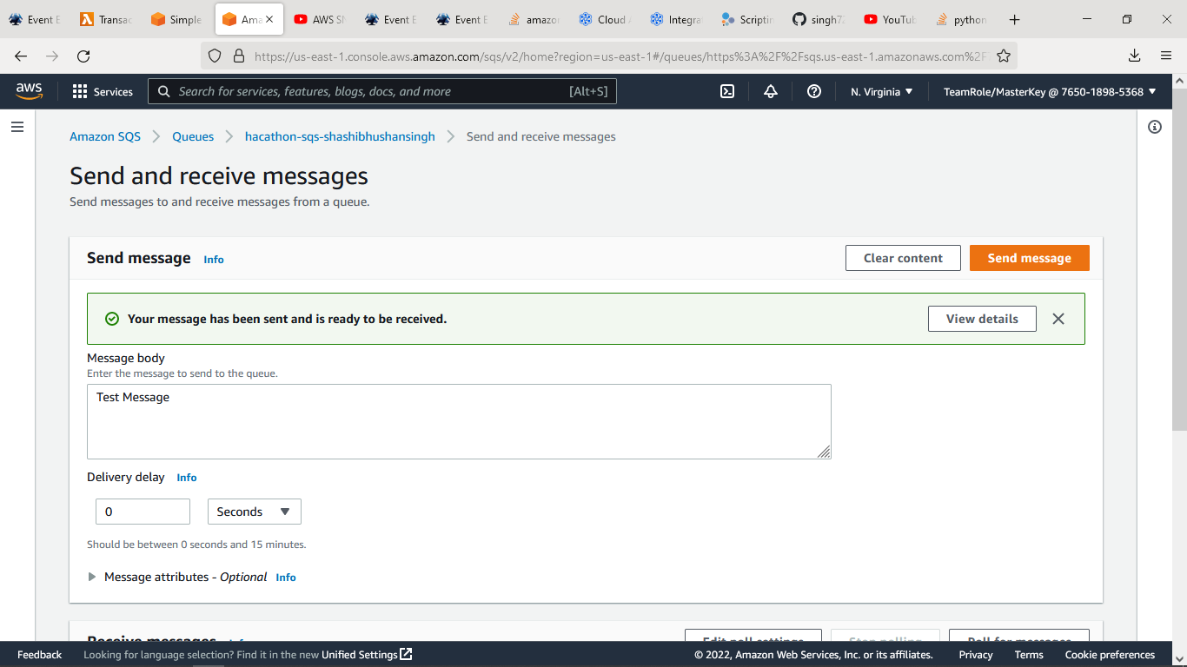

Thank you!